Decision Trees - Results

1. Decision Tree classifier on Iris Dataset:

Accuracy of Decision Tree classifier on training set: 1.00

Accuracy of Decision Tree classifier on test set: 0.95

Decision Tree Classifier model with max depth = 3:

Accuracy of Decision Tree classifier on training set: 0.98

Accuracy of Decision Tree classifier on test set: 0.97

Importance of features of the Iris dataset:

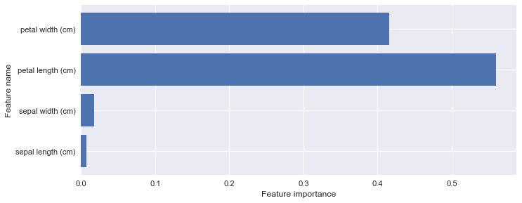

Feature importances: [ 0.00670338 0.01787567 0.55984437 0.41557658]

1. Class Regions of the Decision Tree Classifier on Iris Dataset:

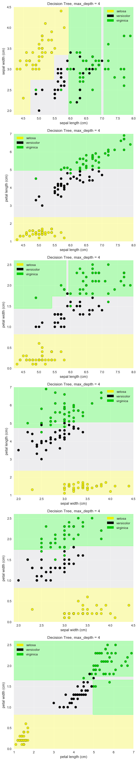

1. Decision Tree Classifier Model on Breast Cancer Dataset:

Breast cancer dataset Decision Tree

Accuracy of DT classifier on training set: 0.96

Accuracy of DT classifier on test set: 0.94

Feature importance of Breast cancer dataset:

